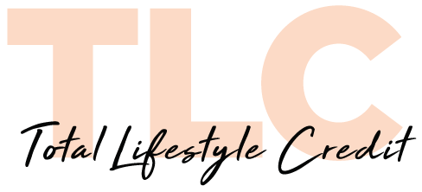

TLC – fund all Jewellery costs and any related fees

- Payment plans from $2,000 to $50,000
- No stress – the whole process is managed privately by our Consultants
- Flexible options – any additional repayments can be added back on to the payment plan at no extra charge
- Fast efficient approvals, simply apply online

Would you like some TLC? – please complete via hyperlink:
https://tlc.com.au/apply-now/?prnid=ODIw

Australian Credit licence 509691

Terms & Conditions:
- Speak to TLC direct for a quote based on your personal circumstances and for the full terms and conditions.
- A full credit and financial assessment would need to be completed prior to acceptance of any offer or product.

